Data Activity 1 - Task 1: The bar chart shows considerable variation in the frequency of COVID-19 reports across Indian states and union territories. Kerala had the highest number of recorded reports in the dataset, substantially exceeding the other regions. Delhi and Telangana were also among the more frequently represented areas, while several states and union territories appeared only a small number of times. This demonstrates how a bar chart can be used to quickly compare the frequency of categorical data across different geographical areas.
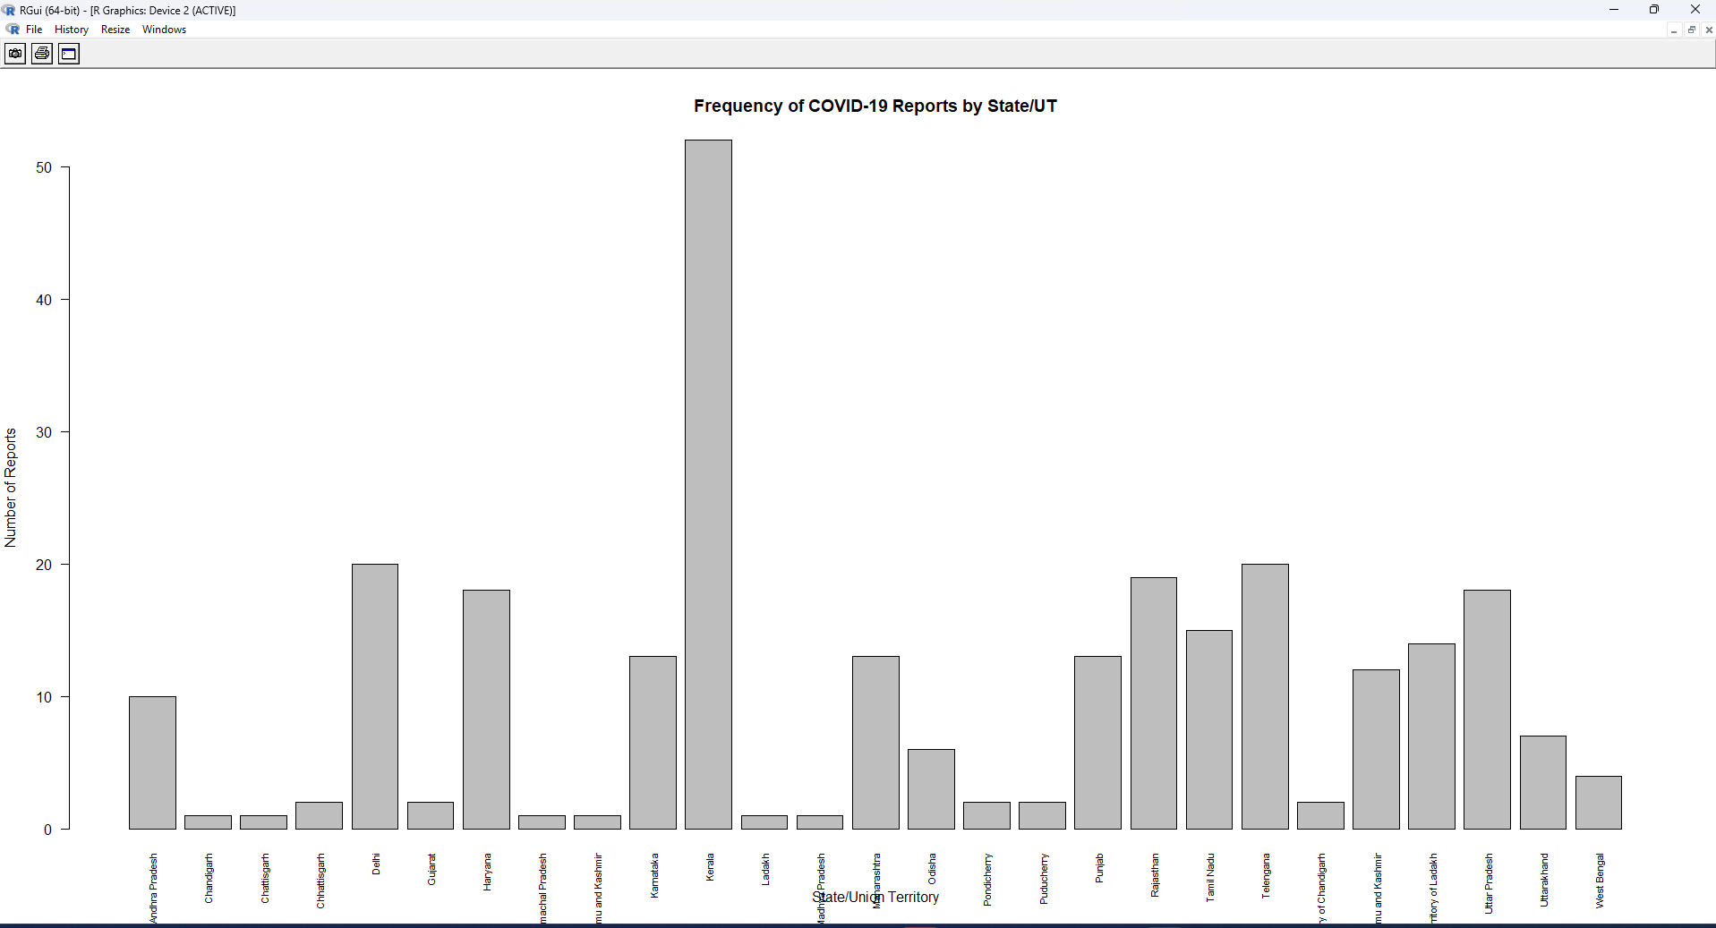

Task 2 - Pie chart of case severity: The pie chart shows that most observations in the dataset fell within the 1–5 confirmed cases category. A smaller proportion recorded between 6 and 15 cases, while relatively few observations had 16 or more cases. This indicates that, during the January–March 2020 period covered by the dataset, most state-level records represented relatively low numbers of confirmed COVID-19 cases.
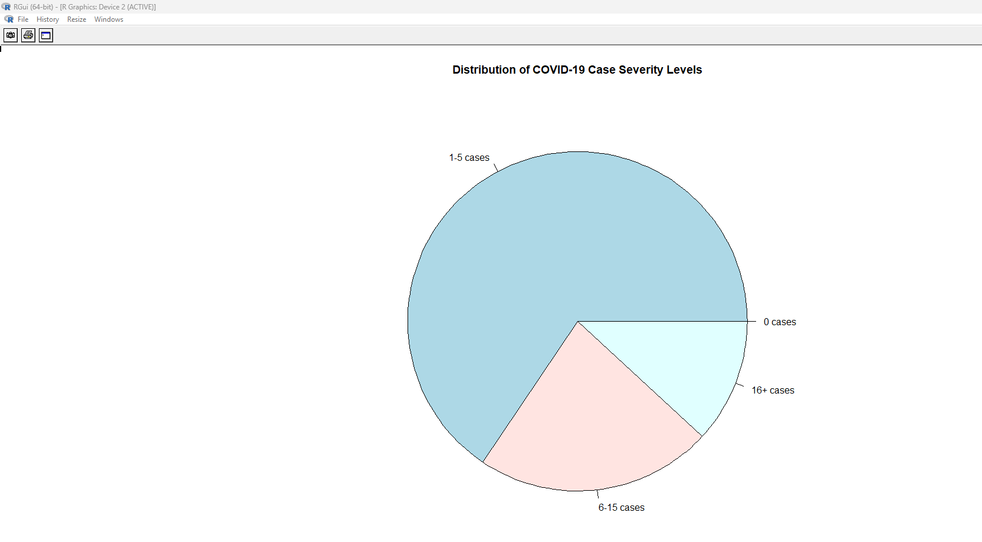

Task 3 - Histogram of recovery numbers: The histogram shows that recovery numbers were heavily concentrated at the lower end of the distribution, with most records reporting very few or no recoveries. Higher recovery numbers occurred much less frequently, resulting in a positively (right) skewed distribution. This is consistent with the dataset representing the early stages of the COVID-19 outbreak in India, when recorded recovery numbers were still relatively low.
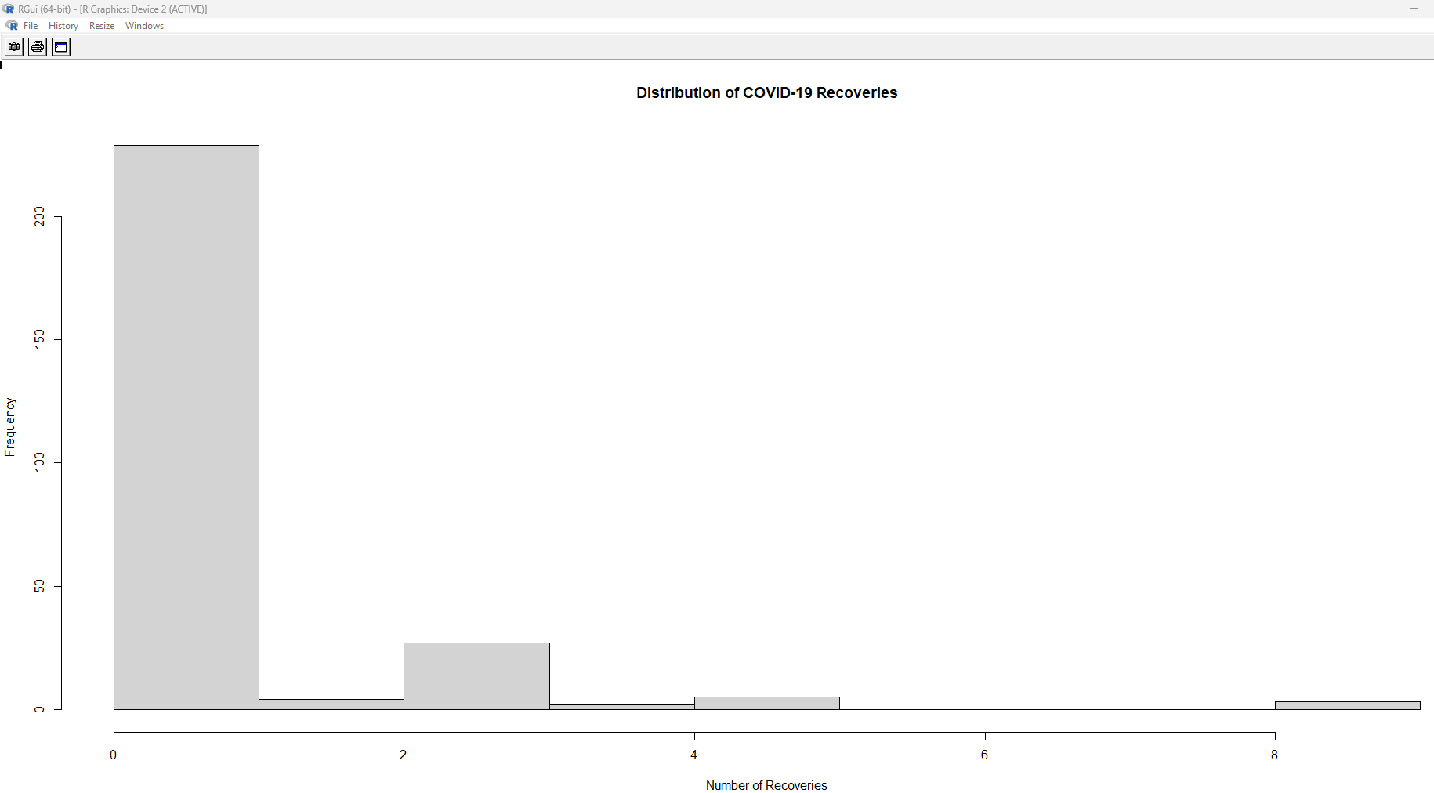

Task 4 - Line chart of total cases over time: The line chart demonstrates a clear upward trend in confirmed COVID-19 cases over time. Case numbers remained relatively low and stable throughout February 2020 but began to increase during early March. The rate of increase became substantially steeper towards the end of the period, demonstrating how a line chart can reveal changes and trends in time-series data.
